Siddhanta Shiromani
Grahaganit adhyaya
Spashtaadhikare Grahaspashtasadhanapakramah
(Section II, Chapter 1 : Determination corrected planetary positions)

Verse No | Translations
1 | The corrected positions of the planets are alone required to decide auspicious moments for journeys, marriages, celebrations of birth etc. For this reason we will now give the methods of correcting the mean positions of the planets so as to agree with their observed positions.  Bimala Prasada Siddhanta Saraswati’s note : In this verse Bhaskara gives us the definitions of corrected position and observed position. For a detailed discussion on this topic please refer to the book “Bange Panjika Sanskara” (correction of Bengali calenders).
2 | The planets lie at the tip of the half-cord (Aardhajyaa) which is an oblique line from the line of the mean position. Hence all the processes pertaining to a planet are carried through this half-chord (Aardhajyaa). From this point onwards we denote half-cord (Aardhajyaa) as chord (Jyaa).  Bimala Prasada Siddhanta Saraswati’s note : Twice the radius of the arc, or the half-line joining the centre with a point on the circumference is called a chord (Jyaa).

Verse No | Translations
3-9 | Bimala Prasada Siddhanta Saraswati’s note : Bhaskara has given a long list of tabular sines (Kramajya) and tabular versed sines (Utkramajya) in verses 3-9. It is given in a tabular form as below.  The last figure, that is 3438 is the chord/tabular sine of 3 signs = 90°  Bimala Prasada Siddhanta Saraswati’s note : The process of determining Jyaa is being described in the beginning of chapters Sfutagativasana and Jyotpatti of Golaadhyaya. According to Shri Surya Siddhanta the sine of 16 minutes of arc is 2978 and that of 8 minutes of arc is 460. Actually they tend to 2977.18 and 460.57 respectively.
  Sine No | Signs/degress of the arc | Chord/Tabular sines | Difference (Δ) | Tabular versed sine (Utkramajya)
  0 | 0 Sign 0° 0′ | 0 | 225 | 0
  1 | 0 Sign 3° 45′ | 225 | 224 | 7
  2 | 0 Sign 7° 30′ | 449 | 222 | 29
  3 | 0 Sign 11° 15′ | 671 | 219 | 66
  4 | 0 Sign 15° 0′ | 890 | 215 | 117
  5 | 0 Sign 18° 45′ | 1105 | 210 | 182
  6 | 0 Sign 22° 30′ | 1315 | 205 | 261
  7 | 0 Sign 26° 15′ | 1520 | 199 | 354
  8 | 1 Sign 0° 0′ | 1719 | 191 | 460
  9 | 1 Sign 3° 45′ | 1910 | 183 | 579
  10 | 1 Sign 7° 30′ | 2093 | 174 | 710
  11 | 1 Sign 11° 15′ | 2267 | 164 | 853
  12 | 1 Sign 15° 0′ | 2431 | 154 | 1007
  13 | 1 Sign 18° 45′ | 2585 | 143 | 1171
  14 | 1 Sign 22° 30′ | 2728 | 131 | 1345
  15 | 1 Sign 26° 15′ | 2859 | 118 | 1528
  16 | 2 Sign 0° 0′ | 2978 | 107 | 1719
  17 | 2 Sign 3° 45′ | 3084 | 93 | 1918
  18 | 2 Sign 7° 30′ | 3177 | 79 | 2123
  19 | 2 Sign 11° 15′ | 3256 | 65 | 2333
  20 | 2 Sign 15° 0′ | 3321 | 51 | 2548
  21 | 2 Sign 18° 45′ | 3372 | 37 | 2767
  22 | 2 Sign 22° 30′ | 3409 | 22 | 2989
  23 | 2 Sign 26° 15′ | 3431 | 7 | 3213
  24 | 3 Sign 0° 0′ | 3438 | -7 | 3438

Verse No | Translations
10 | The difference of two sines (tabular and versed tabular) is called Jyaakhanda (Δ). Sum of all Jyaakhanda gives us the diameter (Vyaasa). If we divide Asu or number of arc by 225 we will have the quotient as the elapsed number of arc minutes.  Bimala Prasada Siddhanta Saraswati’s note : If we divide a circle in four halves we have 90° in each of the halves. We imagine 24 arcs in each of the halves and corresponding number of chords are being mentioned as before. To determine the arc of a degree we have to see in which quadrant (half) it lies and what is its equivalent degree in that half. If the quadrant be even, then it is being required to be subtracted from 90° and the remainder should be multiplied by 60 to convert it to Kalaas (minutes).
11 | [Bimala Prasada Siddhanta Saraswati’s note : The arc that has been determined is called Jata or Gata Dhanu (preceding) and the remaining arc is called Eshya or Gamya Dhanu (following)] If we multiply the difference of Gata and Gamya Dhanu with the remainder of division as mentioned earlier and divide this product by 225 we will have a result. If we add to this result the sine of the arc that has past (Gata Dhanu jyaa) we will have the desired sine.  [Bimala Prasada Siddhanta Saraswati’s note : To determine the arc from the sine] take the difference of desired sine from the sine of the arc (the largest) and multiply it with 225 to have a result. Divide this result by the difference of sine of the arc that has past and the arc to be to yield the final result.
12 | If we multiply the previously determined number of arcs by 225 and add to this the result obtained in the previous verse we will have the Kalaas (minutes) of the desired arc. The greatest declination is 24° and its sine is 1397. [Bimala Prasada Siddhanta Saraswati’s note : According to the Western Scholars the Greatest declination was 23°27′8.26″. Each year it decreases by 468 Vikalaas (seconds). Major General A. W. Dreshan has mentioned this result in his calculation of greatest declination]. To simplify calculations we can use Laghukshandas to determine the sine.
13-14 | The Laghukshandas are respectively 21, 20, 19, 17, 15, 12, 9, 5, 2. If we divide the degrees by 10 we will have the intervals of sine (Jyaakshanda). If we multiply these with the remainders and divide that product with 10 and add them to the previous remainders we will have successive difference of sine (Laghujyaa). The Laghujyaa of 24° is 48′45″. We fix the tabular versed sine (Utkramajyaa) starting to calculate from the end of the above mentioned figure.  Bimala Prasada Siddhanta Saraswati’s note : The modern scholars use decimal system to determine the sines. According to them the sines for 10° intervals are respectively 0.174, 0.342, 0.500, 0.643, 0.766, 0.866, 0.940, 0.985 and 1.000. We get the Laghujyaas if we multiply each with 120. If the difference of sines is Kshanda then we can easily calculate them. As per Laghujyaa calculation we have the radius as 120; generally radius is taken to be 3438. Hence for each successive difference of sines (Laghujyaa) the normal sine is 28′39″. The greatest declination is generally 1397; if we multiply this by 120 and divide the product by 3438 we will have 48′45″.
15 | We successively subtract the Differntials/Kshandas (Δ) starting from the beginning from the successive difference of sines (Laghujyaa), at a certain point we will reach a stage where no further subtraction is possible. Then the remainder is multiplied by 10 and divided by the uncorrected Kshandas to yeild a quotient which when added to 10 times preceeding Kshanda will yeild the arc-measure in Degrees.

Verse No | Translations
16 | If the remainder be multiplied by the difference of preceding (Gata) and following (Gamya) difference (Kshanda) we will have a product. If this product be divided by 20 and then this quotient be subtracted from the half of the sum of preceding (Gata) and following (Gamya) difference (Kshanda) we will have a rectification coefficient (Bhogya) for Tabular and Versed Tabular Sines.  Bimala Prasada Siddhanta Saraswati’s note : If s₀, s₁, s₂ be three sines and d₁ (=s₁-s₀) and d₂ (=s₂-s₁) be difference of sines bet ween them (Jyaakshanda/Δ) and A be the remainder of arc then,  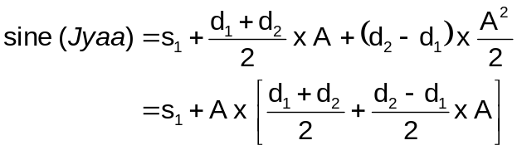  The part in the parenthesis is the rectification co-efficient. For a detailed explanation please see Lunar tables as calculated by Hansen.
17 | (During the calculation of arc) As described earlier, if we subtract the Kshandas successively and take the remainder, divide it by 2 and multiply this product by the difference of preceding (Gata) and following (Gamya) difference (Kshanda), divide by the following difference (Gamya Kshanda) and as described earlier, this be subtracted from the half of the sum of preceding (Gata) and following (Gamya) difference (Kshanda) for Tabular Arc and added to the half of the sum of preceding (Gata) and following (Gamya) difference (Kshanda) for Versed Tabular Arc we will have the rectification coefficient (Bhogya Kshanda) for the calculation of arc.  Bimala Prasada Siddhanta Saraswati’s note : This follows from the above equation.
18 | If we subtract the apex of slowest motion (Mandocca) from the mean position of a planet we will have the Anomaly (Mandakendra) of the planet. Similary if the mean position of the planet be subtracted from the apex of fastest motion (Sighrocca) we will have the Commutation (Shighrakendra). If the Anomaly be in the Libra then it should be positive and if it is in in Aries it should be negitive. For Commutation however the reverse happens, that is negitive in Libra and positive in Aries.
19 | Three signs (3X30° = 90°) make a quadrant (Pada). Four Padas make one circle (4 x 90° = 360°). The Quadrants are named odd and even alternatively. In an odd quadrant preceding degrees and in a even quadrant the following degrees is called a base (of a right angled triangle). If we subtract this base from three signs we have the perpendicular (of a right angled triangle).
20 | If we succesively subtract Bhujajya (RSine of base of a right-angled Triangle) and Kotijya (RCos of an angle) from Radius (Trijya) we will have the Tabular Versed sines of base and perpendicular of the right-angled triangle. If we subtract the Tabular Versed sines of base and perpendicular of the right-angled triangle from the Radius (Trijya) we will have the tabular sines of base and perpendicular of the right-angled triangle.

Verse No | Translations
21 | If from the square of the radius we subtract the square of RSine of Base or RCos and take the square root of the result we have the result approximately equal to Rsine or RCos respectively. Similarly we can calculate the Day-radius (Dyujyaa), Rsine of Declination (Krantijyaa), Rsine of Zenith Distance (Drigjyaa), Cone (Shanku) and Radius (Trijyaa).
22 | The circumference of the Manda (slowest motion) epicycle for Sun is 13°40′, for moon is 31°36′, for Mars is 70°, for Mercury 38°, for Jupiter 33°, for Venus 11° and for Saturn 50°.
23-25 | The circumference of the Shighra (fastest motion) epicycle for Mars is 243°40′, for Mercury 132°, for Jupiter 68°, for Venus 258° and for Saturn 40°. If we divide twice the Rsine of the anomaly for Venus by 3438 and subtract this resu;lt from the circumference of the Manda epicycle, we will have their corrected circumference. Similarly if we divide five times the Rsine of the commutation for Venus by 3438 and add this result to the Shighra epicycle we will have its corrected circumference. Based on the quadrant in which the first Anomaly occurs for Mars determine the preceeding and following, then take the smallest of these two and multiply its sine with 6°40′ and divide that by 2431 (sine of 45°) and add this result in case of Aquarius and subtract this for cancer to get the corrected aphelion position of Mars. If we subtract the result in degrees from the Shighra epicycle we will have the corrected Shighra circumference.
26 | If we multiply its own circumference with Rsine and Rcos and divide the products respectively by 360 we have the Bhujaphala and Kotiphala respectively. If we multiply Antyaphalajya with Rsine and Rcos and divide this product by radius we will have sine of Rsine of base and Rcos of base.  Bimala Prasada Siddhanta Saraswati’s Note :  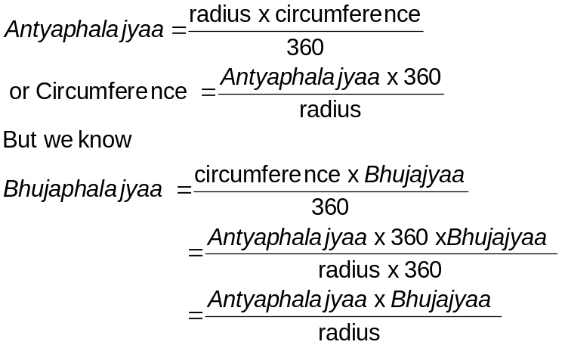

Verse No | Translations
27 | In Aquarius we add Rcos with Antyaphalajyaa and in Cancer we take the difference of Rcos and Antyaphalajyaa to yield us a result. Now to the square of this result if we add square of Rsine and take the square root of this sum we will have the hypotenuse.  Bimala Prasada Siddhanta Saraswati’s note : If we know length of two sides and the angle subtend between them, then determination of the third side is known as determination of the hypotenuse (Karna). We denote one side as Radius (of a circle) and the other as Antyaphalajyaa. We then produce Antyaphalajyaa and draw a perpendicular at the other end of the Radius, this perpendicular is known as Bhujajyaa (Rsine). The line joining this perpendicular and Antyphalajyaa is known as Kotijyaa (Rcos). Similarly if we produce the radius and drop a perpendicular from the other point of Antyaphalajyaa to the Radius, then the perpendicular is called Bhujaphala and the line from the base of this perpendicular to the Radius (where the circle cuts the produced radius) is called Kotiphala. Now in simple equation terms we have :  (Hypotenuse)² = (Antyaphalajyaa)² + (Radius)² + 2 x Antyaphalajyaa x Kotijyaa  but (Radius)² = (Bhujajyaa)² + (Kotijyaa)²  hence we have,  (Hypotenuse)² = (Antyaphalajyaa)² + (Bhujajyaa)² + (Kotijyaa)² + 2 x Antyaphalajyaa x Kotijyaa  = (Bhujajyaa)² + [(Antyaphalajyaa)² + (Kotijyaa)² + 2 x Antyaphalajyaa x Kotijyaa]  = (Bhujajyaa)² + [(Antyaphalajyaa) + (Kotijyaa)]²  As Kotijyaa (Rcos) is positive in Aquarius and negative in Cancer, we have to take their difference in Cancer.
28-29 | Similarly if we add the radius and Kotiphala in Aquarius and take their difference in Cancer, we will have a result. To the square of this result if we add the square of Bhujaphala and take the square root of the sum we will have the hypotenuse.  Bimala Prasada Siddhanta Saraswati’s note : If we substitute (Bhujaphala + Kotiphala)² in place of Antyaphalajyaa and Radius x Kotiphala in place of Antyaphalajyaa x Kotijyaa we will have from the above equation :  (Hypotenuse)² = (Bhujaphala)² + [(Radius)² + (Kotiphala)² + 2 x Radius x Kotiphala]  = (Bhujaphala)² + [(Radius) + (Kotiphala)]²
28-29 | Similarly if we add the radius and Kotiphala in Aquarius and take their difference in Cancer, we will have a result. To the square of this result if we add the square of Bhujaphala and take the square root of the sum we will have the hypotenuse.

Verse No | Translations
30 | If the sine of mean anomaly (Laghubhujajyaa) of Sun be multiplied by 20 and divided by 1103 we will have the equation of the centre for Sun (Mandafala) in degrees. Similarly if the sine of mean anomaly (Laghubhujajyaa) of Moon be multiplied by 20 and divided by 477 we will have the equation of the centre for moon (Mandafala) in degrees.  Bimala Prasada Siddhanta Saraswati’s note :  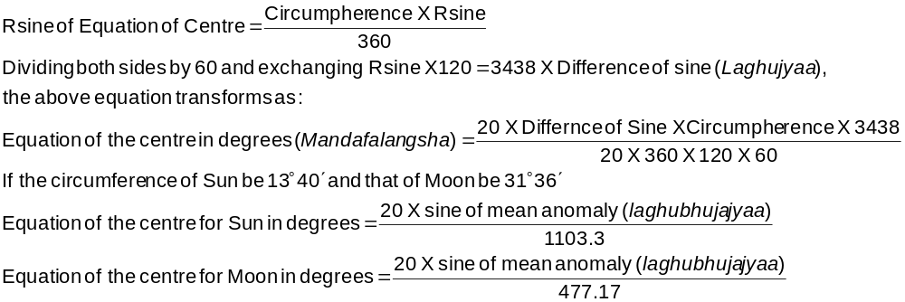
31 | For sun if the cosine of mean anomaly (Laghukotijyaa) be divided by 54 and for moon if the cosine of mean anomaly (Laghukotijyaa) be multiplied by 4 and then divided by 7 gives us a factor opf the motion for sun and moon. This factor should be added in Cancer and should be subtracted in Capricorn and we will get the corrected motion of sun and moon.  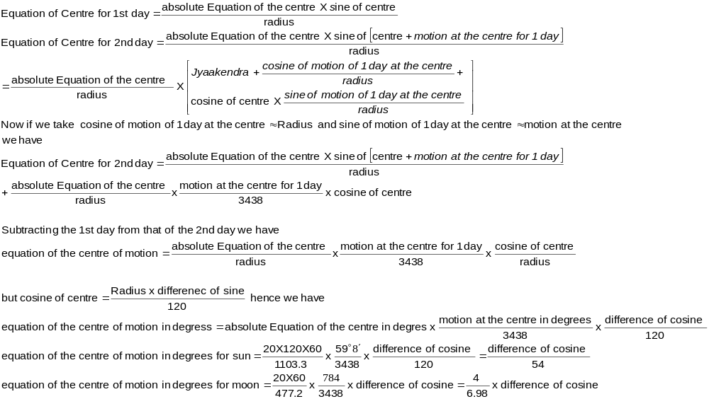Bimala Prasada Siddhanta Saraswati’s note :  Note : This formulaworkout is wrong in many places, had innumerable printing mistakes and also contained unexplained terms and items

Verse No | Translations
32 | If we multiply Bhujaphala with the radius or Multiply Rsine with Antyaphalajyaa and divide this product by the hypotenuse we have a result which is a sine which when converted to arc gives us the equation of conjunction.  Bimala Prasada Siddhanta Saraswati’s note :  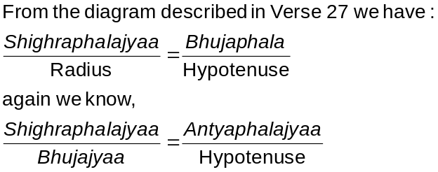
33 | If we multiply the Rsine with the Radius and divide this product by the hypotenuse we will have a result, which when converted to arc and subtracted from the base gives us the equation of conjunction (Shighraphala). The arc of the radius and the sine of equation of conjunction (Shighraphalajyaa) would be added to one another in odd quadrants and subtracted from one another in even quadrants to yield their quadrants of the eccentric circle. Its sine is preceding arcs in the odd quadrants and following arcs in even quadrant.  Bimala Prasada Siddhanta Saraswati’s note :  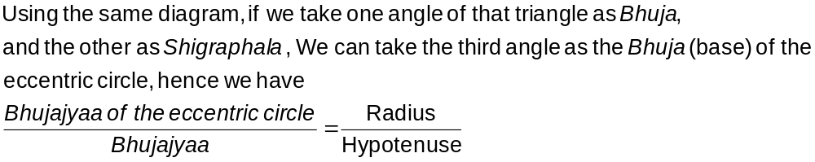
34-35 | If we correct the mean position of the planet with the first equation of the centre (Prathama Mandaphala) we will have Manda corrected motion. If we subtract this Manda corrected motion from the apex of fastest motion we will have the commutation which is then used to determine the Shighra Hypotenuse. Using this correction on the Manda corrected motion we will have the corrected position of the planet. Again taking this as the mean position and repeating the correction we will have the corrected position and motion. For Mars we use half of the first two corrections and full for the last two corrections. As Sun and Moon does not have apex of fastest motion so if we do their Manda correction we will have their corrected position.
36 | The difference in position of the corrected planetary position for one day is the instantaneous corrected motion for a planet.

Verse No | Translations
37 | If the daily motion of the mean anomaly (Mandakendra) is multiplied by Kotiphala and divided by radius and the result is then added in Cancer to the mean daily motion and subtracted from the mean daily motion in Capricorn then we will have the Manda corrected motion of the planet.  Bimala Prasada Siddhanta Saraswati’s note :  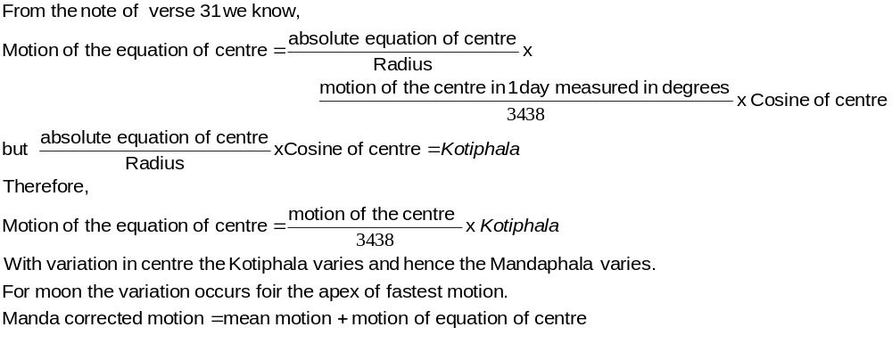
38 | In the case of the moon, obtaining the true moon for a particular moment and his daily motion for the day, the ending moment of the lunar day (tithi) near at hand is to be computed with that daily motion, and the method of successive approximations is to be used to rectify the ending moment. In the case of the ending moment of the tithi being sufficiently away, then it does not matter even if the daily motion is applied to get the approximate ending moment. In as much as the Moon’s daily motion is great and varies from moment to moment the motion at the moment is to be used.
39 | Subtract the Shighraphala in degrees from 90° and determine the sine of the remainder. Multiply this sine with the motion of the commutation and divide that product by the Shighra hypotenuse. The result thus obtained when subtracted from the apex of fastest motion gives us the corrected motion. If this subtraction be impossible then subtract the apex of fastest motion from it and find the retrograde motion.
40 | The Shighragatiphala calculation given in the book Lalla dhivriddhitantra is considered incorrect by the scholars. This is because the Shighragatiphala is zero for 90° and 270° and for 0° it has a Shighragatiphala.
41 | If the commutation for Mars is 163, for Mercury is 145, for Jupiter is 125, for Venus is 165 and for Saturn is 113 then we have their retrograde motion. This retrograde motion ends at a degree given by subtraction of their beginning of retrograde degrees from 360. (For non retrograde Mars is 197, Mercury is 215, Jupiter is 235, Venus is 195 and Saturn is 247).
Hence ends the chapter named Spashtaadhikare Grahaspashtasadhanapakramah
of Grahaganita part of Siddhanta Shiromani

Asu= 4 seconds of sidereal time; 1 minute of arc (part of the 5400 Asava cosntituting a quarter of the sidereal day);
Laghukshanda = differntials. Although Bimala Prasad Siddhanta Saraswati refers to this he does not provide any detailed information about this.
The specific term used by Bimala Prasad Siddhanta Saraswati is Bhuja
The specific term used by Bimala Prasad Siddhanta Saraswati is Koti
It is difficult to define Bhujaphala and Kotiphala, they should be depicted pictorially. If we procude the radius of a circle and draw a perpendicular on this produced radius and join it with the point where the radius cuts the circumference of the circle it then forms a right angled triangle. The base of this right angled triangle is Kotiphala and its perpendicular is Bhujaphala. 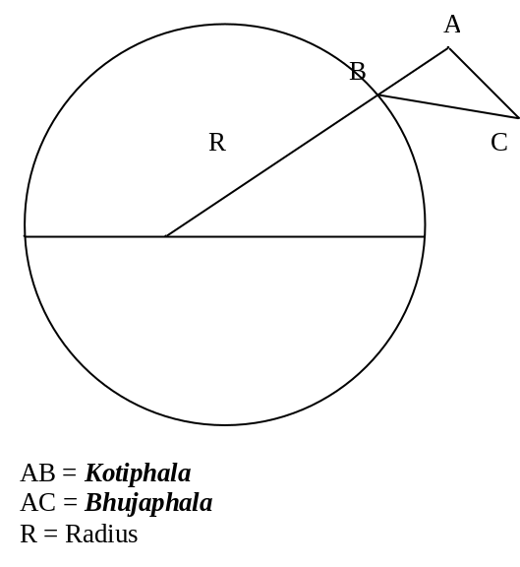
Antyaphalajyaa = Sine of Maximum correction due to apex of slowest motion (Mandocca) or maximum correction due to apex of fastest motion (Shighrocca) . The former is equal to sine of radius of Manda epicycle and the later is equal to sine of radius of Shighra epicycle.
This part is mutilated, from the context I take it as Bhukti or daily motion.

